library(readxl)
> # Import data
> data <- read_excel("D://R//data.xlsx")
> head(data)
# A tibble: 6 × 13
State NDIR Unemp Wage Crime Income Metrop Poor Taxes Educ BusFail Temp Region
<chr> <dbl> <dbl> <dbl> <dbl> <dbl> <dbl> <dbl> <dbl> <dbl> <dbl> <dbl> <chr>
1 Alabama 17.5 6 10.8 780 27196 67.4 16.4 1553 66.9 0.2 62.8 South
2 Arizona 49.6 6.4 11.2 715 31293 84.7 15.9 2122 78.7 0.51 61.1 West
3 Arkansas 23.6 5.3 9.65 593 25565 44.7 15.3 1590 66.3 0.08 59.6 South
4 California -37.2 8.6 12.4 1078 35331 96.7 17.9 2396 76.2 0.63 59.2 West
5 Colorado 53.2 4.2 12.3 567 37833 81.8 9 2092 84.4 0.42 43.4 West
6 Connectic… -38.4 5.6 13.5 456 41097 95.7 10.8 3334 79.2 0.33 48.6 North…
> data=as.data.frame(data)
> head(data)
State NDIR Unemp Wage Crime Income Metrop Poor Taxes Educ BusFail Temp
1 Alabama 17.47 6.0 10.75 780 27196 67.4 16.4 1553 66.9 0.20 62.77
2 Arizona 49.60 6.4 11.17 715 31293 84.7 15.9 2122 78.7 0.51 61.09
3 Arkansas 23.62 5.3 9.65 593 25565 44.7 15.3 1590 66.3 0.08 59.57
4 California -37.21 8.6 12.44 1078 35331 96.7 17.9 2396 76.2 0.63 59.25
5 Colorado 53.17 4.2 12.27 567 37833 81.8 9.0 2092 84.4 0.42 43.43
6 Connecticut -38.41 5.6 13.53 456 41097 95.7 10.8 3334 79.2 0.33 48.63
Region
1 South
2 West
3 South
4 West
5 West
6 Northeast
> # Convert categorical variable
> data$Region <- as.factor(data$Region)
> data$Region
[1] South West South West West Northeast South South
[9] South West Midwest Midwest Midwest Midwest South South
[17] Northeast South Northeast Midwest Midwest South Midwest West
[25] Midwest West Northeast Northeast Midwest Northeast South Midwest
[33] Midwest South West Northeast Northeast South Midwest South
[41] South West Northeast South Midwest South Midwest West
Levels: Midwest Northeast South West
> data$Region=as.character(data$Region)
> data$Region
[1] "South" "West" "South" "West" "West" "Northeast" "South"
[8] "South" "South" "West" "Midwest" "Midwest" "Midwest" "Midwest"
[15] "South" "South" "Northeast" "South" "Northeast" "Midwest" "Midwest"
[22] "South" "Midwest" "West" "Midwest" "West" "Northeast" "Northeast"
[29] "Midwest" "Northeast" "South" "Midwest" "Midwest" "South" "West"
[36] "Northeast" "Northeast" "South" "Midwest" "South" "South" "West"
[43] "Northeast" "South" "Midwest" "South" "Midwest" "West"
> # Summary
> summary(data)
State NDIR Unemp Wage Crime
Length:48 Min. :-45.460 Min. :2.900 Min. : 9.19 Min. : 82.0
Class :character 1st Qu.: -5.405 1st Qu.:4.875 1st Qu.:10.89 1st Qu.: 326.8
Mode :character Median : 9.250 Median :5.450 Median :11.82 Median : 509.5
Mean : 10.889 Mean :5.579 Mean :11.85 Mean : 568.4
3rd Qu.: 29.152 3rd Qu.:6.325 3rd Qu.:12.52 3rd Qu.: 769.5
Max. :128.520 Max. :8.900 Max. :16.13 Max. :1206.0
Income Metrop Poor Taxes Educ
Min. :23564 Min. : 24.00 Min. : 7.60 Min. :1535 Min. :64.30
1st Qu.:28560 1st Qu.: 50.08 1st Qu.:10.38 1st Qu.:1844 1st Qu.:73.45
Median :31665 Median : 69.55 Median :12.45 Median :2124 Median :76.70
Mean :31994 Mean : 67.17 Mean :13.22 Mean :2158 Mean :75.99
3rd Qu.:35296 3rd Qu.: 83.92 3rd Qu.:15.38 3rd Qu.:2345 3rd Qu.:80.03
Max. :42280 Max. :100.00 Max. :25.70 Max. :3655 Max. :85.10
BusFail Temp Region
Min. :0.080 Min. :38.53 Length:48
1st Qu.:0.190 1st Qu.:44.56 Class :character
Median :0.265 Median :50.88 Mode :character
Mean :0.284 Mean :51.39
3rd Qu.:0.360 3rd Qu.:57.90
Max. :0.630 Max. :70.64
> plot(data)
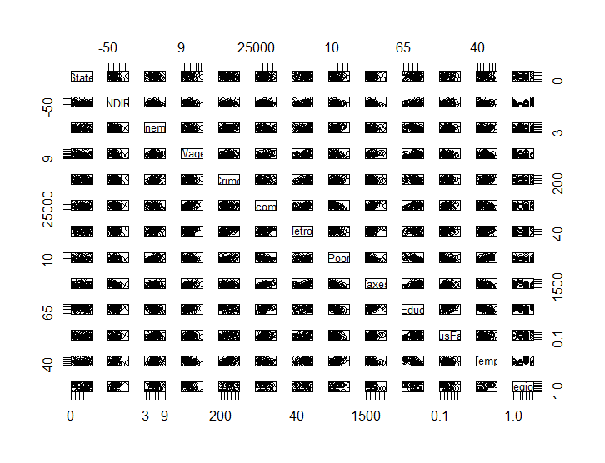
>plot(data$NDIR) 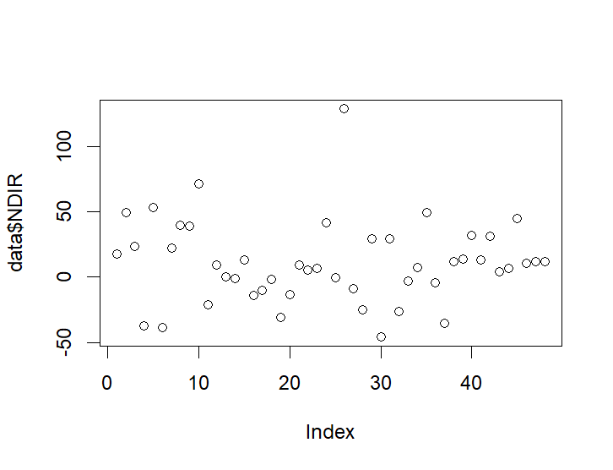
> hist(data$NDIR)

>>>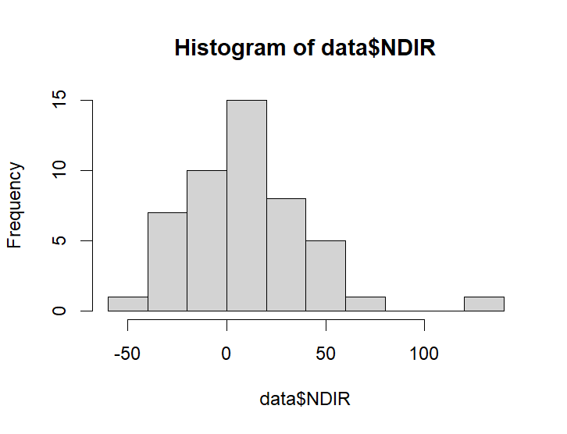

>> str(data)
'data.frame': 48 obs. of 13 variables:
$ State : chr "Alabama" "Arizona" "Arkansas" "California" ...
$ NDIR : num 17.5 49.6 23.6 -37.2 53.2 ...
$ Unemp : num 6 6.4 5.3 8.6 4.2 5.6 4.9 6.6 5.2 5.6 ...
$ Wage : num 10.75 11.17 9.65 12.44 12.27 ...
$ Crime : num 780 715 593 1078 567 ...
$ Income : num 27196 31293 25565 35331 37833 ...
$ Metrop : num 67.4 84.7 44.7 96.7 81.8 95.7 82.7 93 67.7 30 ...
$ Poor : num 16.4 15.9 15.3 17.9 9 10.8 8.3 14.9 14 12 ...
$ Taxes : num 1553 2122 1590 2396 2092 ...
$ Educ : num 66.9 78.7 66.3 76.2 84.4 79.2 77.5 74.4 70.9 79.7 ...
$ BusFail: num 0.2 0.51 0.08 0.63 0.42 0.33 0.19 0.36 0.33 0.31 ...
$ Temp : num 62.8 61.1 59.6 59.2 43.4 ...
$ Region : chr "South" "West" "South" "West" ...
> # Correlation
> numeric_data <- data[, sapply(data, is.numeric)]
> cor(numeric_data)
NDIR Unemp Wage Crime Income Metrop
NDIR 1.000000000 -0.1734248 -0.17996702 0.006695305 -0.15841382 -0.185906056
Unemp -0.173424803 1.0000000 0.15190516 0.418812292 -0.18012310 0.283713350
Wage -0.179967016 0.1519052 1.00000000 0.033607952 0.43492620 0.362234362
Crime 0.006695305 0.4188123 0.03360795 1.000000000 0.03738319 0.639199999
Income -0.158413821 -0.1801231 0.43492620 0.037383193 1.00000000 0.535257254
Metrop -0.185906056 0.2837134 0.36223436 0.639199999 0.53525725 1.000000000
Poor -0.037387326 0.5243184 -0.17235689 0.486201309 -0.66737060 -0.007264947
Taxes -0.407066586 0.1104949 0.46028397 0.102648629 0.69187514 0.486035981
Educ 0.102625998 -0.4049360 0.37510460 -0.326421300 0.59443850 0.047333217
BusFail -0.046273584 0.2525150 0.12680291 0.173823901 0.39860364 0.405805582
Temp 0.074669207 0.4059877 -0.32310168 0.654216836 -0.33388765 0.307424859
Poor Taxes Educ BusFail Temp
NDIR -0.037387326 -0.4070666 0.10262600 -0.04627358 0.07466921
Unemp 0.524318447 0.1104949 -0.40493602 0.25251501 0.40598770
Wage -0.172356892 0.4602840 0.37510460 0.12680291 -0.32310168
Crime 0.486201309 0.1026486 -0.32642130 0.17382390 0.65421684
Income -0.667370599 0.6918751 0.59443850 0.39860364 -0.33388765
Metrop -0.007264947 0.4860360 0.04733322 0.40580558 0.30742486
Poor 1.000000000 -0.3756128 -0.68225443 -0.10787052 0.63150104
Taxes -0.375612771 1.0000000 0.44719084 0.41060573 -0.38578815
Educ -0.682254434 0.4471908 1.00000000 0.39247110 -0.68512420
BusFail -0.107870515 0.4106057 0.39247110 1.00000000 -0.02993122
Temp 0.631501039 -0.3857882 -0.68512420 -0.02993122 1.00000000
> print(round(cor(numeric_data),3))
NDIR Unemp Wage Crime Income Metrop Poor Taxes Educ BusFail Temp
NDIR 1.000 -0.173 -0.180 0.007 -0.158 -0.186 -0.037 -0.407 0.103 -0.046 0.075
Unemp -0.173 1.000 0.152 0.419 -0.180 0.284 0.524 0.110 -0.405 0.253 0.406
Wage -0.180 0.152 1.000 0.034 0.435 0.362 -0.172 0.460 0.375 0.127 -0.323
Crime 0.007 0.419 0.034 1.000 0.037 0.639 0.486 0.103 -0.326 0.174 0.654
Income -0.158 -0.180 0.435 0.037 1.000 0.535 -0.667 0.692 0.594 0.399 -0.334
Metrop -0.186 0.284 0.362 0.639 0.535 1.000 -0.007 0.486 0.047 0.406 0.307
Poor -0.037 0.524 -0.172 0.486 -0.667 -0.007 1.000 -0.376 -0.682 -0.108 0.632
Taxes -0.407 0.110 0.460 0.103 0.692 0.486 -0.376 1.000 0.447 0.411 -0.386
Educ 0.103 -0.405 0.375 -0.326 0.594 0.047 -0.682 0.447 1.000 0.392 -0.685
BusFail -0.046 0.253 0.127 0.174 0.399 0.406 -0.108 0.411 0.392 1.000 -0.030
Temp 0.075 0.406 -0.323 0.654 -0.334 0.307 0.632 -0.386 -0.685 -0.030 1.000
> library(corrplot)
> # Correlation plot
> corrplot(cor(numeric_data), method = "color", type = "lower",
+ addCoef.col = "black", number.cex = 0.7,
+ tl.col = "black", tl.srt = 45,
+ title = "Correlation Matrix — Domestic Immigration Data",
+ mar = c(0,0,2,0))
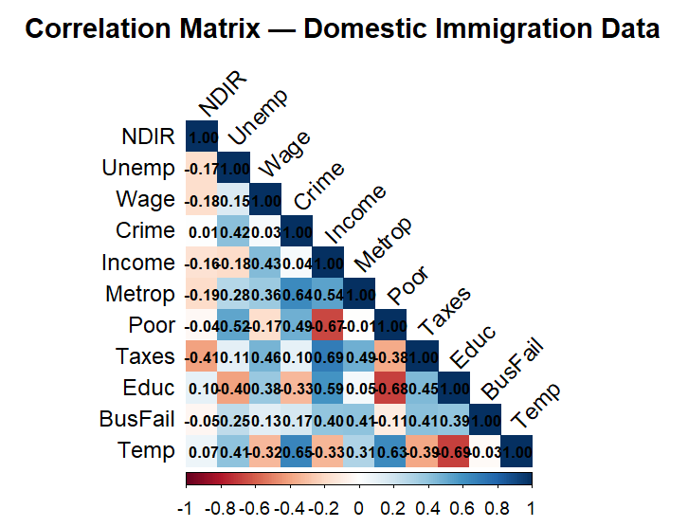
>pairs(numeric_data)
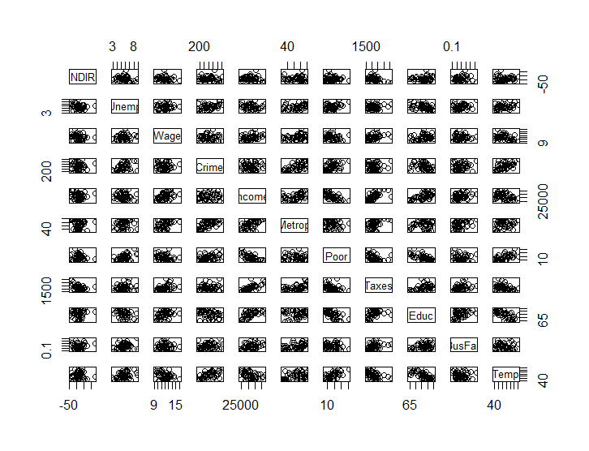

> # Full regression model
> full_model <- lm(NDIR ~ Unemp+Wage+Crime+Income+Metrop+Poor+Taxes+Educ+BusFail+Temp+Region, data = data)
> summary(full_model)

Call:
lm(formula = NDIR ~ Unemp + Wage + Crime + Income + Metrop +
Poor + Taxes + Educ + BusFail + Temp + Region, data = data)

Residuals:
Min 1Q Median 3Q Max
-63.482 -11.247 0.669 10.081 84.102

Coefficients:
Estimate Std. Error t value Pr(>|t|)
(Intercept) 82.162026 152.589586 0.538 0.5938
Unemp -1.412005 5.320072 -0.265 0.7923
Wage -0.392768 4.104865 -0.096 0.9243
Crime 0.019582 0.024911 0.786 0.4373
Income -0.001768 0.002001 -0.883 0.3832
Metrop -0.005842 0.361036 -0.016 0.9872
Poor -2.582832 2.232436 -1.157 0.2554
Taxes -0.013083 0.018001 -0.727 0.4723
Educ 0.619873 1.748421 0.355 0.7251
BusFail 14.945494 48.352929 0.309 0.7591
Temp -0.216802 1.261855 -0.172 0.8646
RegionNortheast -16.828637 17.723509 -0.950 0.3491
RegionSouth 16.567194 16.795183 0.986 0.3309
RegionWest 36.835774 13.813717 2.667 0.0116 *
---
Signif. codes: 0 ‘***’ 0.001 ‘**’ 0.01 ‘*’ 0.05 ‘.’ 0.1 ‘ ’ 1

Residual standard error: 25.67 on 34 degrees of freedom
Multiple R-squared: 0.518, Adjusted R-squared: 0.3337
F-statistic: 2.811 on 13 and 34 DF, p-value: 0.007804

> par(mfrow=c(2,2))
> plot(full_mode
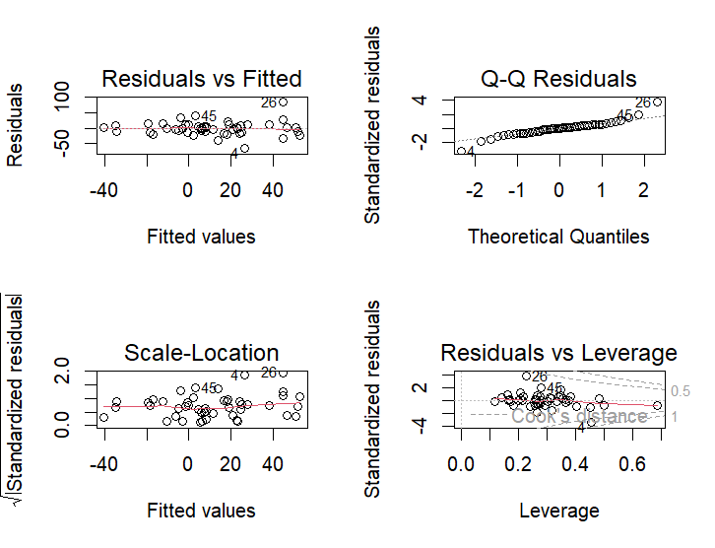
>
######
> anova(full_model)
Analysis of Variance Table

Response: NDIR
Df Sum Sq Mean Sq F value Pr(>F)
Unemp 1 1397.6 1397.6 2.1217 0.154401
Wage 1 1122.6 1122.6 1.7042 0.200511
Crime 1 314.0 314.0 0.4767 0.494592
Income 1 1051.6 1051.6 1.5964 0.215003
Metrop 1 801.9 801.9 1.2173 0.277645
Poor 1 1777.4 1777.4 2.6982 0.109681
Taxes 1 5741.6 5741.6 8.7162 0.005682 **
Educ 1 3296.8 3296.8 5.0047 0.031942 *
BusFail 1 17.3 17.3 0.0263 0.872233
Temp 1 15.2 15.2 0.0230 0.880296
Region 3 8536.4 2845.5 4.3196 0.011022 *
Residuals 34 22396.8 658.7
---
Signif. codes: 0 ‘***’ 0.001 ‘**’ 0.01 ‘*’ 0.05 ‘.’ 0.1 ‘ ’ 1
> library(car)
> vif(full_model)
GVIF Df GVIF^(1/(2*Df))
Unemp 3.231885 1 1.797745
Wage 2.428673 1 1.558420
Crime 3.921486 1 1.980274
Income 5.482520 1 2.341478
Metrop 4.365315 1 2.089334
Poor 5.505197 1 2.346316
Taxes 4.302824 1 2.074325
Educ 6.629424 1 2.574767
BusFail 2.271343 1 1.507097
Temp 7.397514 1 2.719837
Region 17.336711 3 1.608772

>

> # Load libraries
> library(car)
> library(ggplot2)
> # Fit regression model
> model <- lm(NDIR ~ Educ + Income + Temp + Wage +
+ Taxes + Unemp + Poor + Metrop +
+ Crime + BusFail + Region,
+ data = data)
> # Calculate VIF
> vif_values <- vif(model)
> # Convert matrix to dataframe
> vif_df <- data.frame(
+ Variable = rownames(vif_values),
+ GVIF = vif_values[,1],
+ Df = vif_values[,2],
+ Adjusted_VIF = vif_values[,3]
+ )
> # Sort by Adjusted VIF
> vif_df <- vif_df[order(vif_df$Adjusted_VIF), ]
> # View table
> print(vif_df)
Variable GVIF Df Adjusted_VIF
BusFail BusFail 2.271343 1 1.507097
Wage Wage 2.428673 1 1.558420
Region Region 17.336711 3 1.608772
Unemp Unemp 3.231885 1 1.797745
Crime Crime 3.921486 1 1.980274
Taxes Taxes 4.302824 1 2.074325
Metrop Metrop 4.365315 1 2.089334
Income Income 5.482520 1 2.341478
Poor Poor 5.505197 1 2.346316
Educ Educ 6.629424 1 2.574767
Temp Temp 7.397514 1 2.719837
> # Plot Adjusted VIF
> ggplot(vif_df,
+ aes(x = reorder(Variable, Adjusted_VIF),
+ y = Adjusted_VIF,
+ fill = Adjusted_VIF)) +
+
+ geom_bar(stat = "identity") +
+
+ coord_flip() +
+
+ geom_hline(yintercept = 5,
+ color = "orange",
+ linetype = "dashed",
+ linewidth = 1) +
+
+ geom_hline(yintercept = 10,
+ color = "red",
+ linetype = "dashed",
+ linewidth = 1) +
+
+ labs(
+ title = "Multicollinearity Check Using VIF",
+ x = "Variables",
+ y = "Adjusted VIF"
+ ) +
+
+ theme_minimal(base_size = 14) +
+
+ theme(
+ plot.title = element_text(face = "bold"),
+ legend.position = "none"
+
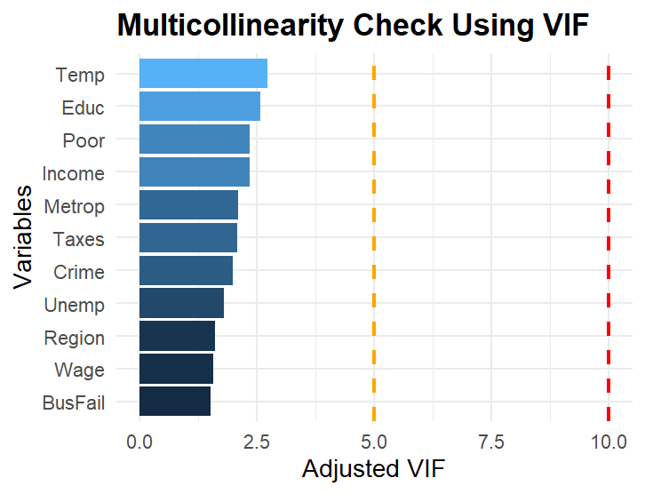
>
> res=residuals(full_model)
> res
1 2 3 4 5 6 7
-3.5359750 11.5134781 0.9536669 -63.4824524 2.6221007 1.7974821 -0.4948122
8 9 10 11 12 13 14
12.0495654 20.9970458 26.5999037 -22.7881137 1.0383436 -5.6710646 -9.0457953
15 16 17 18 19 20 21
5.4264888 -13.0446994 0.6365546 -17.9324887 -12.1169411 -8.0633038 11.0225684
22 23 24 25 26 27 28
-0.2501044 0.7010786 -10.3754490 -18.4186167 84.1023953 -2.5358326 9.8642676
29 30 31 32 33 34 35
32.8109653 -10.9564212 10.7314057 -40.2742467 -0.4721363 -16.8355458 3.0592707
36 37 38 39 40 41 42
15.3176373 -18.3955467 -12.9559474 5.6955094 7.5465475 5.7110062 -21.5048167
43 44 45 46 47 48
16.3888001 -4.5725440 41.4849796 6.2063906 11.9798323 -32.5344303
> plot(full_model$fitted.values,
+ residuals(full_model))
> abline(h = 0, col = "red")

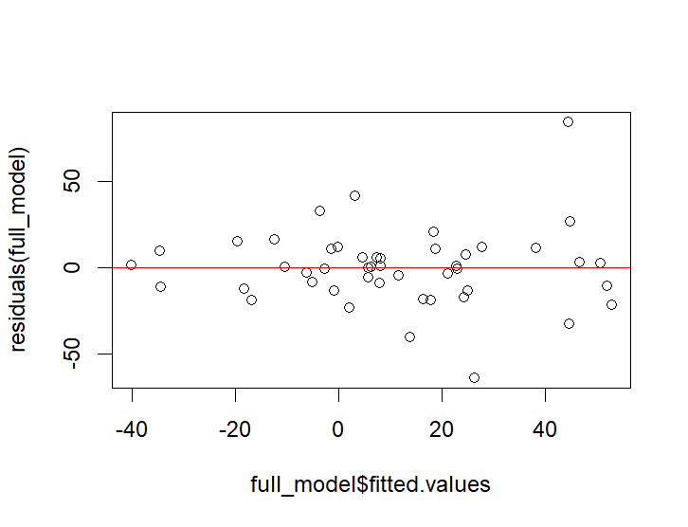
>
shapiro.test(res)

Shapiro-Wilk normality test

data: res
W = 0.91102, p-value = 0.001455

> hist(res)
> qqnorm(res)
> qqline(res)

>

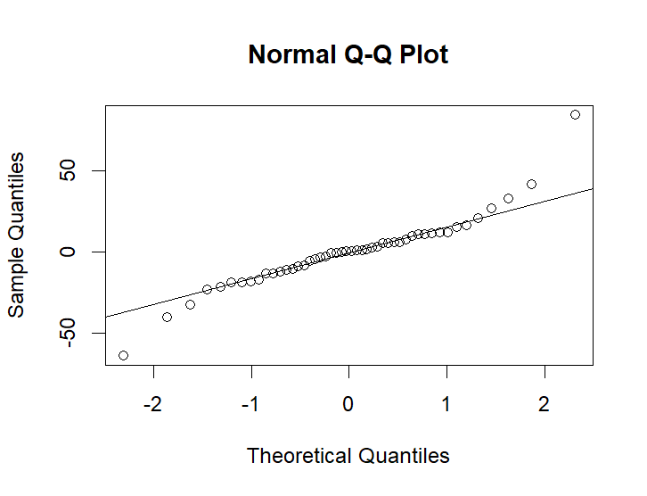
>> library(lmtest)
> bptest(full_model)

studentized Breusch-Pagan test

data: full_model
BP = 21.87, df = 13, p-value = 0.05741

> dwtest(full_model)

Durbin-Watson test

data: full_model
DW = 2.2151, p-value = 0.7407
alternative hypothesis: true autocorrelation is greater than 0

> durbinWatsonTest(full_model)
lag Autocorrelation D-W Statistic p-value
1 -0.1314445 2.21507 0.504
Alternative hypothesis: rho != 0
> ###########
> rstudent(full_model)
1 2 3 4 5 6 7
-0.14450635 0.54587529 0.04004960 -4.02186051 0.11707791 0.08648844 -0.02235838
8 9 10 11 12 13 14
0.59180804 0.89028325 1.16978410 -1.01942021 0.04628781 -0.23915989 -0.40267465
15 16 17 18 19 20 21
0.25151085 -0.71313967 0.03088817 -0.82720150 -0.54494945 -0.38898678 0.49884345
22 23 24 25 26 27 28
-0.01128666 0.03007147 -0.46925946 -0.78883383 4.77590447 -0.11932088 0.45663607
29 30 31 32 33 34 35
1.61867618 -0.75786388 0.44533112 -1.89688921 -0.02042447 -0.75677404 0.12879002
36 37 38 39 40 41 42
0.69063485 -0.92646908 -0.58460415 0.27204126 0.32548533 0.24641416 -1.13348436
43 44 45 46 47 48
0.78620215 -0.21026783 1.98160227 0.33183014 0.52128026 -1.56335398
> which(abs(rstudent(full_model)) > 2)
4 26
4 26
> boxplot(rstudent(full_model),
+ main = "Studentized Residuals")

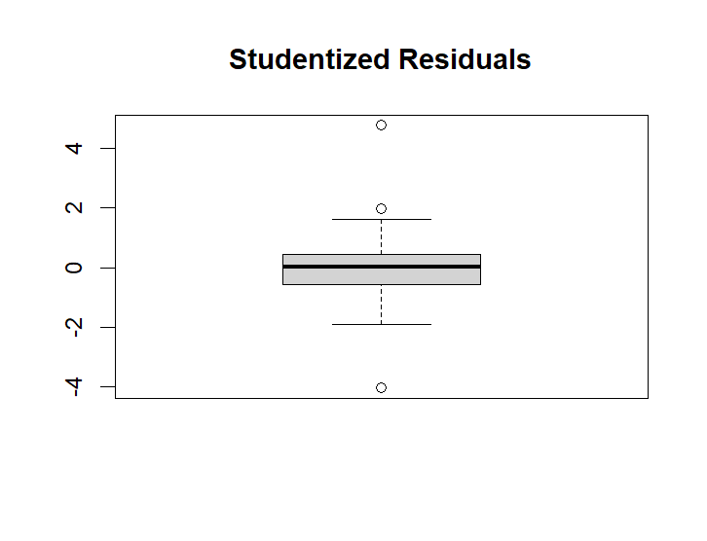
>> boxplot(rstudent(full_model),
+ main = "Studentized Residuals")
> # Cook's distance
> cooksd <- cooks.distance(full_model)
> # Plot Cook's distance
> plot(cooksd,
+ type = "h",
+ main = "Cook's Distance")
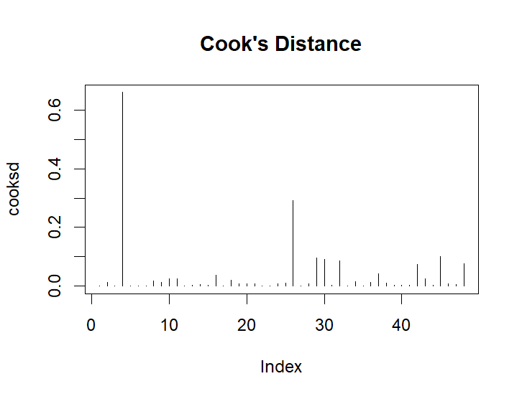
>
> # Influential observations
> which(cooksd > (4/nrow(data)))
4 26 29 30 32 45
4 26 29 30 32 45
> # Hat values
> hatvalues(full_model)
1 2 3 4 5 6 7 8
0.1172318 0.3386100 0.1645014 0.4529658 0.2606388 0.3634406 0.2783376 0.3827039
9 10 11 12 13 14 15 16
0.1607426 0.2065465 0.2405427 0.2585111 0.1700880 0.2527927 0.3127994 0.4994029
17 18 19 20 21 22 23 24
0.3742122 0.2931959 0.2649924 0.3639802 0.2751850 0.2764960 0.1991274 0.2748905
25 26 27 28 29 30 31 32
0.1815665 0.2272744 0.3342318 0.3080858 0.3465281 0.6866885 0.1392505 0.2633791
33 34 35 36 37 38 39 40
0.2126533 0.2581402 0.1682034 0.2647308 0.4040048 0.2688329 0.3527144 0.2053914
41 42 43 44 45 46 47 48
0.2070975 0.4489952 0.3477520 0.3022834 0.2773910 0.4828450 0.2154008 0.3146239
> # High leverage points
> which(hatvalues(full_model) > (2*length(full_model$coefficients)/nrow(data)))
30
30
> ###
> dffits(full_model)
1 2 3 4 5 6
-0.052660653 0.390584046 0.017770926 -3.659758812 0.069513024 0.065351456
7 8 9 10 11 12
-0.013885428 0.465978166 0.389624361 0.596834444 -0.573716847 0.027330899
13 14 15 16 17 18
-0.108270239 -0.234215685 0.169686734 -0.712288490 0.023885680 -0.532771135
19 20 21 22 23 24
-0.327210378 -0.294264890 0.307371150 -0.006977332 0.014994724 -0.288929008
25 26 27 28 29 30
-0.371545256 2.590110297 -0.084543218 0.304705211 1.178733944 -1.121974454
31 32 33 34 35 36
0.179119568 -1.134254692 -0.010614607 -0.446409182 0.057914992 0.414407481
37 38 39 40 41 42
-0.762786100 -0.354482471 0.200816048 0.165480161 0.125934053 -1.023195578
43 44 45 46 47 48
0.574067159 -0.138401381 1.227752945 0.320633829 0.273130998 -1.059226174
> ###
> dfbetas(full_model)
(Intercept) Unemp Wage Crime Income Metrop
1 -0.0204787167 0.0072099439 -0.0093861650 -0.0121498202 0.0097807717 -0.002388985
2 -0.0484697622 -0.0722701897 0.0245424462 -0.1362258129 -0.0760191228 0.023244038
3 0.0063996828 -0.0026412690 -0.0005240451 0.0028874746 -0.0038129851 -0.002817896
4 -0.3575153128 -0.8902454352 0.0736550074 -0.0346919113 -1.0313888983 0.678092793
5 0.0095160372 -0.0146233146 -0.0045268525 0.0093107052 0.0116674365 0.021449214
6 -0.0213960270 -0.0169711755 0.0058618684 -0.0305442074 0.0128008948 0.002045588
7 0.0019125720 0.0007680278 -0.0058321970 -0.0017368707 0.0034688721 0.000489291
8 -0.1237823878 0.0985551381 -0.0976870173 0.1088485281 -0.1900491037 0.019314750
9 0.0488263543 -0.1022150320 0.0274534611 -0.0257520163 0.0022633031 -0.131534354
10 0.0798546166 0.0379276931 0.0783769229 0.0944532809 0.1450033125 -0.286429900
11 -0.0607925580 -0.2038399880 0.1210118899 -0.2496456526 -0.1609885993 0.077476033
12 0.0049029634 -0.0096063204 0.0160251420 -0.0014733574 -0.0149348778 0.004410868
13 0.0197276080 0.0287751597 -0.0325645601 -0.0015607238 -0.0159754727 0.060099949
14 0.0740145289 0.0125263224 -0.0427957034 0.0237996923 0.0777936263 0.052945069
15 0.0843505256 -0.0902573685 0.0720217344 -0.0207811526 -0.0050453903 -0.022043341
16 0.3801727566 -0.0291491077 -0.0884705048 -0.0330846221 -0.1047143377 -0.063013711
17 -0.0017723598 0.0142613578 -0.0035476568 0.0035466391 -0.0022163770 -0.003788963
18 0.0950925870 -0.0249271530 0.0007624707 -0.1869509954 -0.1219193643 0.040344106
19 0.0084817875 -0.0193254002 0.0225437100 -0.1400260365 -0.1231150775 0.004858597
20 -0.0672187732 0.0229467948 -0.1688853703 -0.1054106754 -0.0499896718 0.048745309
21 -0.0607128632 -0.0004706086 -0.1063853075 -0.1037017347 -0.0189126864 0.130404625
22 0.0008059045 -0.0011146279 0.0016688484 0.0025703051 -0.0027520811 0.001828234
23 0.0032201415 -0.0033676982 0.0026119051 0.0049589658 0.0026551828 -0.001773307
24 -0.0080910604 0.0452461453 -0.1062445224 -0.0441196997 0.1044143249 0.064722319
25 -0.0132847705 0.1259999097 0.0052783071 -0.0241480966 0.1076715179 0.059812019
26 1.1388184907 0.4891854551 -0.4473268240 0.9766363698 0.2594916161 0.106420079
27 -0.0050370462 0.0231163845 -0.0166875749 -0.0003427189 0.0075599385 0.006187449
28 -0.0396533000 0.0375957162 0.0343792530 -0.0648311486 0.1234395726 -0.063135774
29 -0.2819035138 0.2382997100 -0.5690952550 0.2963721469 0.2153780328 -0.151627420
30 -0.1965191383 0.2622476072 0.0792865353 -0.2825793081 0.4234470174 -0.070743505
31 0.0357090085 -0.0914817739 -0.0137189976 -0.0079924138 -0.0261697554 0.013546792
32 -0.6370285058 -0.0856612695 0.4689649065 0.1746097549 0.2239642528 -0.327292307
33 0.0001050658 0.0013378491 -0.0054594664 0.0027886884 0.0006243232 -0.001877759
34 0.0424388729 0.0660946829 -0.0717469833 -0.0293481160 0.1462977335 -0.009355025
35 0.0008519062 -0.0092127387 0.0045712118 -0.0054064653 -0.0272605196 0.021205210
36 0.0099391794 -0.0658363571 0.0603994363 -0.0598646941 -0.0931538675 0.193770416
37 -0.3118916139 -0.2153623405 0.2747194699 0.1998801921 0.2006358298 -0.420290289
38 -0.0556367208 -0.1280292224 0.0950917043 -0.1851944556 -0.0155381038 0.044004919
39 0.0142083140 -0.0178522911 -0.1019089070 -0.0107059399 0.0904800019 0.005628575
40 0.1203930027 -0.0746580604 0.0265612545 0.0583187478 -0.0306156299 0.011726012
41 -0.0532960206 0.0027683414 -0.0302399170 -0.0543036136 0.0315329787 0.036866038
42 0.3103342774 0.0282582531 0.2952678926 0.2725895126 -0.0516620455 -0.566217971
43 -0.1202039779 -0.0521041812 0.1051323284 0.1154282765 0.1629795963 -0.389313594
44 0.0324275245 -0.0326115312 0.0528820971 0.0724617235 -0.0782662185 -0.032079190
45 -0.4437362537 0.6076466732 0.0648070380 -0.2117657415 -0.2188901934 0.231006235
46 0.0222934320 0.1907410511 -0.0162501383 -0.1166432785 -0.0133333351 0.045554239
47 0.0701737634 0.0741561162 -0.0671727184 -0.1062891304 0.0399112860 0.032854232
48 0.2857606498 -0.1855995987 -0.0020390894 -0.0250172864 -0.0536356351 0.514513959
Poor Taxes Educ BusFail Temp RegionNortheast
1 0.0150341125 0.0152987386 0.0160554143 -0.0030030163 -0.003203698 -0.0096423289
2 -0.0098736335 0.1111474229 -0.0314826447 0.0871851054 0.222462024 -0.0343097108
3 -0.0053297773 0.0022131161 -0.0049055060 -0.0042270617 0.002997658 0.0019185188
4 0.0759238211 -0.1482273967 1.1959171327 -1.7325406602 -0.264922005 1.3825159482
5 0.0142602905 -0.0288447091 0.0026563854 0.0133101359 -0.033871684 0.0105508669
6 0.0215989738 0.0317200805 -0.0010695062 -0.0158007454 0.023620306 0.0116107845
7 0.0057424597 -0.0022834327 -0.0015631047 0.0015924119 -0.001831844 0.0001068238
8 -0.1761506816 0.0596842626 0.1887360940 -0.0259104689 0.148742111 -0.0208349942
9 -0.1149714155 0.1394012149 -0.1305718554 0.1641060092 0.182048970 -0.0946963835
10 0.0081137896 -0.0493774018 -0.1145458182 0.1033509318 -0.080449899 -0.0138675324
11 0.1319060540 0.0699377620 0.0539153810 0.1798712108 0.026949839 0.2020302127
12 -0.0086692440 0.0005191876 -0.0051902562 -0.0002772441 0.009958686 0.0017285937
13 0.0085533259 -0.0263356089 0.0059964521 0.0107840637 -0.052409284 0.0191405352
14 0.0215084476 -0.0463331764 -0.0630907177 -0.0830675452 -0.099847580 0.0451167208
15 0.0198048429 0.0319895510 -0.1093974387 0.0683155703 -0.013578915 0.0068342869
16 -0.4494186132 0.2302443212 -0.3398197406 0.3229646831 0.040566732 -0.3199630355
17 -0.0055580761 -0.0055644266 0.0069779199 -0.0015139317 -0.004904351 0.0046078461
18 -0.0186643528 0.0109358613 -0.1109627988 -0.0175960704 0.180176247 0.0409758452
19 -0.0465239930 0.1806650910 -0.0342981164 -0.0360531465 0.116320895 -0.1450737723
20 0.0062595621 0.0775576975 0.0970849770 -0.0633945331 0.083470631 0.0278544964
21 0.1187950158 0.1049511581 0.1067604391 -0.0943836516 -0.097809146 -0.0802096201
22 -0.0019595601 -0.0007672588 0.0008226755 0.0017596473 -0.002122589 0.0006715401
23 0.0003016217 -0.0071735124 -0.0035393986 0.0003666176 0.001457361 0.0011893326
24 0.0318324953 -0.0172265075 -0.0206622700 0.0339564938 0.001639257 -0.0822321970
25 0.1122082832 -0.0886724638 -0.0247949059 -0.0352829579 -0.116994938 0.0646011141
26 -0.6800094434 -0.2489648340 -0.8509360122 0.4473688088 -0.912258549 -0.6123420172
27 0.0040093255 0.0239524671 -0.0019117227 -0.0484992666 0.003391353 -0.0350261422
28 -0.0318997053 0.0578408630 -0.0812439202 -0.0335321470 0.135189318 -0.0026160069
29 0.5150213515 -0.0348156877 0.3989361948 -0.2533245896 -0.161449853 -0.0888366422
30 -0.1236220651 -0.6096092899 0.0643062482 -0.0039532950 0.274597100 -0.2076648757
31 -0.0001355249 0.0617316438 -0.0335841942 -0.0227985694 0.025242837 0.0166993332
32 0.1888350881 -0.0999641110 0.2548244279 -0.2531151496 0.496506912 0.4915541631
33 0.0004920827 0.0011484836 0.0020033822 0.0016372884 -0.003372817 0.0009784088
34 -0.0255721316 0.0532065326 -0.1149433196 -0.2467762905 0.070414290 -0.0604452280
35 -0.0018112078 0.0089850147 0.0085333457 -0.0090140028 -0.003063912 0.0087258133
36 0.0530628398 -0.1383519983 0.0356555935 -0.1217690386 -0.004861167 0.2833699255
37 0.2300903646 0.0310052618 0.1516929882 0.0097784408 0.083277222 -0.0088256161
38 0.1416374156 0.0733350388 -0.0024502694 0.1265993796 0.017826638 0.0077496584
39 0.1062058759 -0.0673405369 0.0164139455 0.0067593596 -0.074858653 -0.0082423664
40 -0.0410581978 -0.0259628754 -0.0915736256 0.0607383113 -0.048297604 0.0205191769
41 0.0733830523 -0.0138419176 0.0421370804 0.0160008663 -0.002057747 -0.0006862059
42 -0.2958724092 0.3181662343 -0.4789064021 0.5888661896 0.076006461 -0.2985897707
43 -0.0097599790 -0.0584903072 0.0406417233 0.0132979730 0.142007826 0.2408950022
44 -0.0392192822 0.0115337642 -0.0175238911 0.0099641671 0.016105298 0.0410077891
45 -0.1840209484 -0.0250903131 0.5138278582 0.0863812033 -0.011844303 -0.4942400012
46 -0.0084220382 0.0101348366 -0.0102094456 -0.0091402247 -0.082213856 -0.0960214011
47 -0.0605871343 0.1023996800 -0.0836108639 0.0161773148 -0.017928992 -0.2115304335
48 0.1515390911 -0.4076928983 -0.1503515018 0.3705235437 -0.325245407 0.1046493284
RegionSouth RegionWest
1 0.002062798 -0.0050789581
2 -0.146905213 0.1577763568
3 -0.001191467 0.0036644605
4 1.159122586 -0.3542499525
5 0.023930265 0.0259719696
6 -0.002715645 0.0148509720
7 -0.005247749 -0.0006255152
8 0.020730801 -0.0982623852
9 -0.041390846 -0.0030314013
10 0.004418547 0.2395355929
11 0.269391146 0.2347023315
12 -0.012170069 0.0008791767
13 0.047587095 0.0236516619
14 0.061250584 0.0906091301
15 0.016188015 0.0601543321
16 -0.196063029 -0.0422637224
17 0.003508411 -0.0072582266
18 -0.314944163 0.0757104859
19 -0.042783602 0.0681175378
20 0.034139899 0.0454075103
21 0.095409762 -0.0446331889
22 0.001289834 -0.0001050868
23 -0.009244874 -0.0036251576
24 -0.046448216 -0.1663054273
25 0.106199040 0.0964052811
26 -0.178646993 0.8514485619
27 -0.012342341 0.0089546725
28 -0.122306591 -0.0088378564
29 -0.208797440 -0.4102016494
30 -0.236814779 -0.2791041316
31 0.034938245 0.0554675430
32 0.035941900 0.2981527157
33 0.005142043 0.0009449036
34 -0.232406385 0.0543402194
35 0.011442459 0.0403512718
36 -0.009239076 0.0818628279
37 0.136863184 0.0272904351
38 0.015483822 0.0528639656
39 -0.006338709 -0.0598082516
40 0.022790064 0.0343512240
41 0.045830191 -0.0166550439
42 -0.225895560 -0.3643115077
43 -0.041961302 -0.0502824615
44 -0.048721088 0.0270726823
45 0.048311059 -0.6670266732
46 0.081885992 -0.0372629105
47 -0.066314935 -0.0927252563
48 0.051857799 -0.3810923784
> plot(full_model,which = 4)
> plot(full_model,which=5)

>

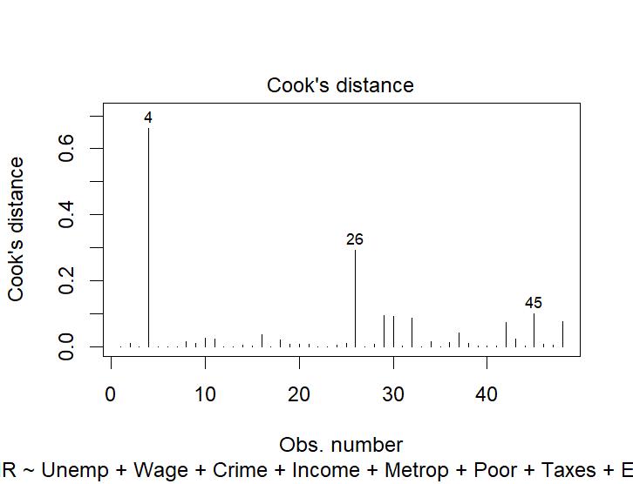
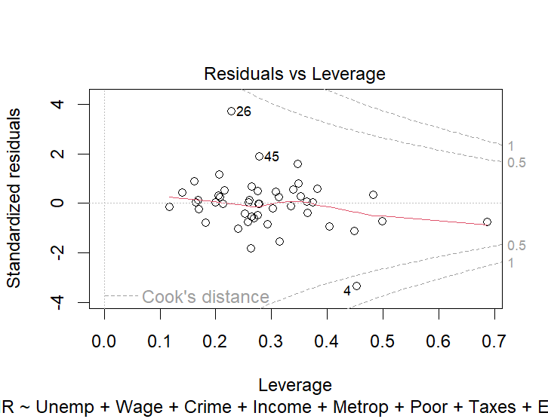
>

> new_data= data[-c(4,26,29,30,32,45),]
> new_data
State NDIR Unemp Wage Crime Income Metrop Poor Taxes Educ BusFail Temp
1 Alabama 17.47 6.0 10.75 780 27196 67.4 16.4 1553 66.9 0.20 62.77
2 Arizona 49.60 6.4 11.17 715 31293 84.7 15.9 2122 78.7 0.51 61.09
3 Arkansas 23.62 5.3 9.65 593 25565 44.7 15.3 1590 66.3 0.08 59.57
5 Colorado 53.17 4.2 12.27 567 37833 81.8 9.0 2092 84.4 0.42 43.43
6 Connecticut -38.41 5.6 13.53 456 41097 95.7 10.8 3334 79.2 0.33 48.63
7 Delaware 22.43 4.9 13.90 686 35873 82.7 8.3 2336 77.5 0.19 54.58
8 Florida 39.73 6.6 9.97 1206 29294 93.0 14.9 2048 74.4 0.36 70.64
9 Georgia 39.24 5.2 10.35 723 31467 67.7 14.0 1999 70.9 0.33 63.54
10 Idaho 71.41 5.6 11.88 282 31536 30.0 12.0 1916 79.7 0.31 42.35
11 Illinois -20.87 5.7 12.26 960 35081 84.0 12.4 2332 76.2 0.18 50.98
12 Indiana 9.04 4.9 13.56 489 27858 71.6 13.7 1919 75.6 0.19 50.88
13 Iowa 0.00 3.7 12.47 326 33079 43.8 10.7 2200 80.1 0.18 45.83
14 Kansas -1.25 5.3 12.14 469 28322 54.6 14.9 2126 81.3 0.42 52.03
15 Kentucky 13.44 5.4 11.82 463 26595 48.5 18.5 1816 64.6 0.22 55.36
16 Louisiana -13.94 8.0 13.13 1062 25676 75.0 25.7 1685 68.3 0.15 65.91
17 Maine -9.77 7.4 11.68 126 30316 35.7 9.4 2281 78.8 0.31 40.23
18 Maryland -1.55 5.1 13.15 998 39198 92.8 10.7 2565 78.4 0.31 54.04
19 Massachusetts -30.46 6.0 12.59 805 40500 96.2 9.7 2664 80.0 0.45 47.35
20 Michigan -13.19 5.9 16.13 792 35284 82.7 14.1 2371 76.8 0.27 43.68
21 Minnesota 9.46 4.0 12.60 327 33644 69.3 11.7 2673 82.4 0.20 39.30
22 Mississippi 5.33 6.6 9.40 434 25400 34.6 19.9 1535 64.3 0.12 63.18
23 Missouri 6.97 4.9 11.78 744 30190 68.3 15.6 1721 73.9 0.23 53.41
24 Montana 41.50 5.1 12.50 178 27631 24.0 11.5 1853 81.0 0.20 40.40
25 Nebraska -0.62 2.9 10.94 339 31794 50.6 8.8 2128 81.8 0.25 46.01
27 New Hampshire -8.72 4.6 11.73 138 35245 59.4 7.7 2305 82.2 0.54 43.53
28 New Jersey -24.90 6.8 13.38 627 42280 100.0 9.2 3051 76.7 0.36 52.72
31 North Carolina 29.46 4.4 10.19 679 30114 66.3 14.2 1975 70.0 0.17 59.36
33 Ohio -3.27 5.5 14.38 504 31855 81.3 14.1 2059 75.7 0.19 50.87
34 Oklahoma 7.37 5.8 11.41 635 26991 60.1 16.7 1777 74.6 0.44 58.36
35 Oregon 49.63 5.4 12.31 503 31456 70.0 11.8 2169 81.5 0.31 46.55
36 Pennsylvania -4.30 6.2 12.49 418 32066 84.8 12.5 2260 74.7 0.26 49.01
37 Rhode Island -35.32 7.1 10.35 402 31928 93.6 10.3 2405 72.0 0.35 49.99
38 South Carolina 11.88 6.3 9.99 1023 29846 69.8 13.8 1736 68.3 0.11 62.53
39 South Dakota 13.71 3.3 9.19 208 29733 32.6 14.5 1668 77.1 0.24 42.89
40 Tennessee 32.11 4.8 10.51 766 28639 67.7 14.6 1684 67.1 0.23 57.75
41 Texas 13.00 6.4 11.14 762 30775 83.9 19.1 1932 72.1 0.39 64.40
42 Utah 31.25 3.7 11.26 301 35716 77.5 8.0 1806 85.1 0.18 46.32
43 Vermont 3.94 4.7 11.54 114 35802 27.0 7.6 2379 80.8 0.30 42.46
44 Virginia 6.94 4.9 11.25 372 37647 77.5 10.7 2073 75.2 0.27 55.55
46 West Virginia 10.75 8.9 12.60 208 23564 41.8 18.6 1752 66.0 0.17 52.25
47 Wisconsin 11.73 4.7 12.41 264 35388 68.1 9.0 2524 78.6 0.24 42.20
48 Wyoming 11.95 5.3 11.81 286 33140 29.7 9.3 2295 83.0 0.19 43.68
Region
1 South
2 West
3 South
5 West
6 Northeast
7 South
8 South
9 South
10 West
11 Midwest
12 Midwest
13 Midwest
14 Midwest
15 South
16 South
17 Northeast
18 South
19 Northeast
20 Midwest
21 Midwest
22 South
23 Midwest
24 West
25 Midwest
27 Northeast
28 Northeast
31 South
33 Midwest
34 South
35 West
36 Northeast
37 Northeast
38 South
39 Midwest
40 South
41 South
42 West
43 Northeast
44 South
46 South
47 Midwest
48 West
> # Summary
> summary(new_data)
State NDIR Unemp Wage Crime
Length:42 Min. :-38.41 Min. :2.900 Min. : 9.19 Min. : 114.0
Class :character 1st Qu.: -2.84 1st Qu.:4.825 1st Qu.:10.99 1st Qu.: 326.2
Mode :character Median : 9.25 Median :5.350 Median :11.81 Median : 496.0
Mean : 10.23 Mean :5.464 Mean :11.85 Mean : 541.2
3rd Qu.: 23.32 3rd Qu.:6.150 3rd Qu.:12.57 3rd Qu.: 738.8
Max. : 71.41 Max. :8.900 Max. :16.13 Max. :1206.0
Income Metrop Poor Taxes Educ
Min. :23564 Min. : 24.00 Min. : 7.60 Min. :1535 Min. :64.30
1st Qu.:28803 1st Qu.: 49.02 1st Qu.: 9.85 1st Qu.:1808 1st Qu.:72.03
Median :31502 Median : 68.80 Median :12.45 Median :2082 Median :76.75
Mean :31998 Mean : 65.96 Mean :12.99 Mean :2112 Mean :75.77
3rd Qu.:35274 3rd Qu.: 82.70 3rd Qu.:14.90 3rd Qu.:2325 3rd Qu.:80.08
Max. :42280 Max. :100.00 Max. :25.70 Max. :3334 Max. :85.10
BusFail Temp Region
Min. :0.0800 Min. :39.30 Length:42
1st Qu.:0.1900 1st Qu.:44.22 Class :character
Median :0.2450 Median :50.93 Mode :character
Mean :0.2702 Mean :51.80
3rd Qu.:0.3300 3rd Qu.:58.21
Max. :0.5400 Max. :70.64
> plot(new_data)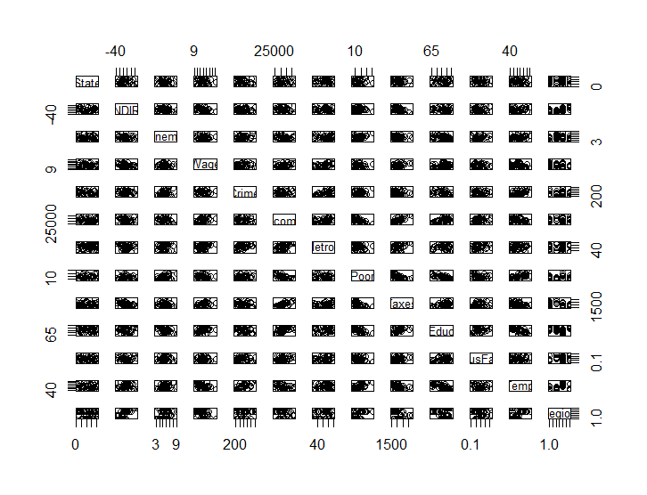
>plot(new_data$NDIR)

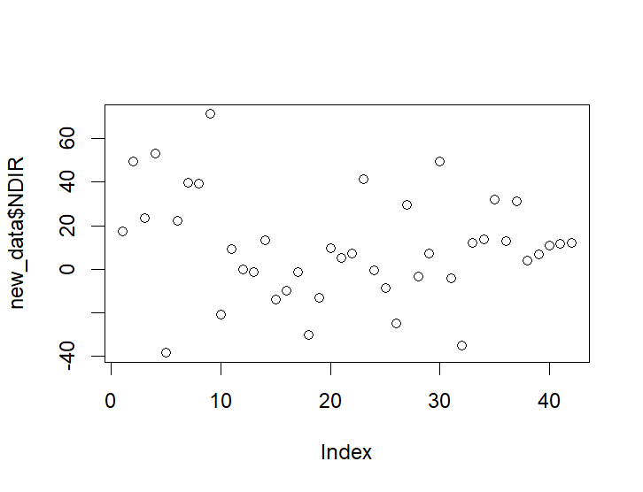

> hist(new_data$NDIR)
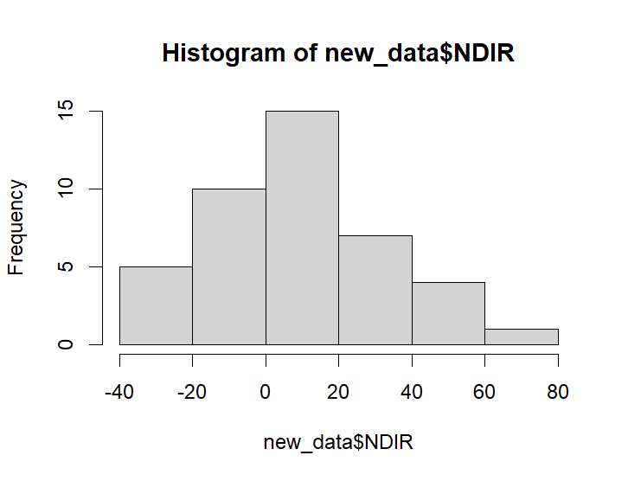
>
> str(new_data)
'data.frame': 42 obs. of 13 variables:
$ State : chr "Alabama" "Arizona" "Arkansas" "Colorado" ...
$ NDIR : num 17.5 49.6 23.6 53.2 -38.4 ...
$ Unemp : num 6 6.4 5.3 4.2 5.6 4.9 6.6 5.2 5.6 5.7 ...
$ Wage : num 10.75 11.17 9.65 12.27 13.53 ...
$ Crime : num 780 715 593 567 456 ...
$ Income : num 27196 31293 25565 37833 41097 ...
$ Metrop : num 67.4 84.7 44.7 81.8 95.7 82.7 93 67.7 30 84 ...
$ Poor : num 16.4 15.9 15.3 9 10.8 8.3 14.9 14 12 12.4 ...
$ Taxes : num 1553 2122 1590 2092 3334 ...
$ Educ : num 66.9 78.7 66.3 84.4 79.2 77.5 74.4 70.9 79.7 76.2 ...
$ BusFail: num 0.2 0.51 0.08 0.42 0.33 0.19 0.36 0.33 0.31 0.18 ...
$ Temp : num 62.8 61.1 59.6 43.4 48.6 ...
$ Region : chr "South" "West" "South" "West" ...
> # Correlation
> numeric_data <- new_data[, sapply(new_data, is.numeric)]

>

> cor(numeric_data)
NDIR Unemp Wage Crime Income Metrop
NDIR 1.00000000 -0.23681830 -0.315823979 -0.013779675 -0.316831449 -0.30333177
Unemp -0.23681830 1.00000000 0.099294516 0.281263421 -0.283555833 0.16789162
Wage -0.31582398 0.09929452 1.000000000 0.009073708 0.407173429 0.31568870
Crime -0.01377968 0.28126342 0.009073708 1.000000000 -0.008423882 0.61774652
Income -0.31683145 -0.28355583 0.407173429 -0.008423882 1.000000000 0.51182097
Metrop -0.30333177 0.16789162 0.315688696 0.617746521 0.511820969 1.00000000
Poor 0.06916084 0.49588757 -0.163684975 0.422166973 -0.721730400 -0.05668567
Taxes -0.50289529 -0.03427259 0.511088122 -0.092582281 0.819550182 0.45113825
Educ 0.03861717 -0.49070733 0.353712429 -0.378117960 0.610829436 0.02205421
BusFail -0.03508756 0.05403278 0.062365822 -0.004434527 0.380229664 0.31301035
Temp 0.11231873 0.40647147 -0.385117981 0.723662062 -0.396460133 0.31593913
Poor Taxes Educ BusFail Temp
NDIR 0.06916084 -0.50289529 0.03861717 -0.035087556 0.11231873
Unemp 0.49588757 -0.03427259 -0.49070733 0.054032781 0.40647147
Wage -0.16368497 0.51108812 0.35371243 0.062365822 -0.38511798
Crime 0.42216697 -0.09258228 -0.37811796 -0.004434527 0.72366206
Income -0.72173040 0.81955018 0.61082944 0.380229664 -0.39646013
Metrop -0.05668567 0.45113825 0.02205421 0.313010352 0.31593913
Poor 1.00000000 -0.59470975 -0.73269393 -0.240073799 0.66962166
Taxes -0.59470975 1.00000000 0.53161670 0.386787642 -0.41940859
Educ -0.73269393 0.53161670 1.00000000 0.422060659 -0.71682197
BusFail -0.24007380 0.38678764 0.42206066 1.000000000 -0.08490228
Temp 0.66962166 -0.41940859 -0.71682197 -0.084902279 1.00000000
> print(round(cor(numeric_data),3))
NDIR Unemp Wage Crime Income Metrop Poor Taxes Educ BusFail Temp
NDIR 1.000 -0.237 -0.316 -0.014 -0.317 -0.303 0.069 -0.503 0.039 -0.035 0.112
Unemp -0.237 1.000 0.099 0.281 -0.284 0.168 0.496 -0.034 -0.491 0.054 0.406
Wage -0.316 0.099 1.000 0.009 0.407 0.316 -0.164 0.511 0.354 0.062 -0.385
Crime -0.014 0.281 0.009 1.000 -0.008 0.618 0.422 -0.093 -0.378 -0.004 0.724
Income -0.317 -0.284 0.407 -0.008 1.000 0.512 -0.722 0.820 0.611 0.380 -0.396
Metrop -0.303 0.168 0.316 0.618 0.512 1.000 -0.057 0.451 0.022 0.313 0.316
Poor 0.069 0.496 -0.164 0.422 -0.722 -0.057 1.000 -0.595 -0.733 -0.240 0.670
Taxes -0.503 -0.034 0.511 -0.093 0.820 0.451 -0.595 1.000 0.532 0.387 -0.419
Educ 0.039 -0.491 0.354 -0.378 0.611 0.022 -0.733 0.532 1.000 0.422 -0.717
BusFail -0.035 0.054 0.062 -0.004 0.380 0.313 -0.240 0.387 0.422 1.000 -0.085
Temp 0.112 0.406 -0.385 0.724 -0.396 0.316 0.670 -0.419 -0.717 -0.085 1.000
> library(corrplot)
> # Correlation plot
> corrplot(cor(numeric_data), method = "color", type = "lower",
+ addCoef.col = "black", number.cex = 0.7,
+ tl.col = "black", tl.srt = 45,
+ title = "Correlation Matrix — Domestic Immigration Data",
+ mar = c(0,0,2,0))

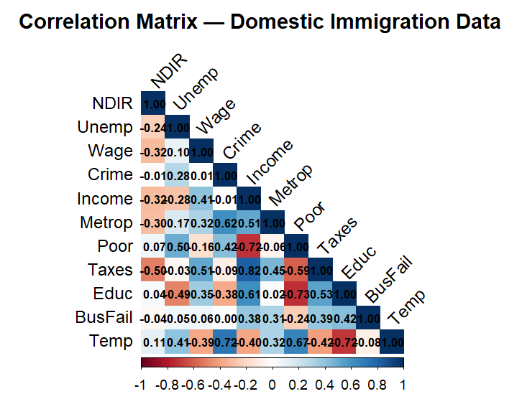
>
> # Full regression model
> full_model <- lm(NDIR ~ Unemp+Wage+Crime+Income+Metrop+Poor+Taxes+Educ+BusFail+Temp+Region, data = new_data)
> summary(full_model)

Call:
lm(formula = NDIR ~ Unemp + Wage + Crime + Income + Metrop +
Poor + Taxes + Educ + BusFail + Temp + Region, data = new_data)

Residuals:
Min 1Q Median 3Q Max
-27.525 -7.345 1.100 6.677 25.701

Coefficients:
Estimate Std. Error t value Pr(>|t|)
(Intercept) 179.007131 95.295337 1.878 0.0708 .
Unemp -4.662178 3.269486 -1.426 0.1649
Wage 0.581917 2.505136 0.232 0.8180
Crime 0.003957 0.015539 0.255 0.8009
Income -0.001716 0.001272 -1.349 0.1881
Metrop -0.086588 0.201185 -0.430 0.6702
Poor -2.431037 1.311274 -1.854 0.0743 .
Taxes -0.001460 0.012782 -0.114 0.9099
Educ -1.218909 1.058662 -1.151 0.2593
BusFail 59.599822 29.051193 2.052 0.0497 *
Temp 0.213542 0.787975 0.271 0.7884
RegionNortheast -18.644831 11.137726 -1.674 0.1053
RegionSouth 11.841403 9.793377 1.209 0.2367
RegionWest 43.105390 8.687459 4.962 3.08e-05 ***
---
Signif. codes: 0 ‘***’ 0.001 ‘**’ 0.01 ‘*’ 0.05 ‘.’ 0.1 ‘ ’ 1

Residual standard error: 13.7 on 28 degrees of freedom
Multiple R-squared: 0.7834, Adjusted R-squared: 0.6829
F-statistic: 7.792 on 13 and 28 DF, p-value: 3.115e-06

> par(mfrow=c(2,2))
> plot(full_model)

>

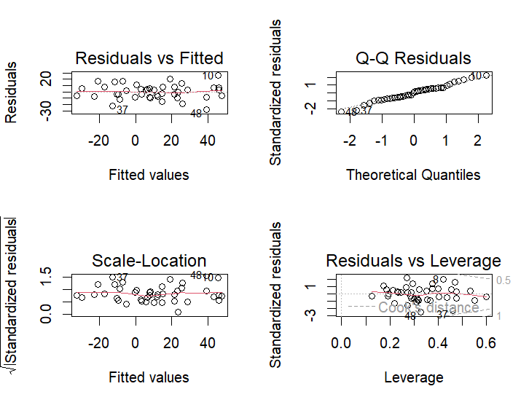
>
> anova(full_model)
Analysis of Variance Table

Response: NDIR
Df Sum Sq Mean Sq F value Pr(>F)
Unemp 1 1360.5 1360.52 7.2514 0.011828 *
Wage 1 2093.4 2093.44 11.1579 0.002381 **
Crime 1 58.9 58.87 0.3138 0.579841
Income 1 2265.7 2265.70 12.0759 0.001682 **
Metrop 1 356.1 356.14 1.8982 0.179191
Poor 1 467.5 467.47 2.4916 0.125691
Taxes 1 2099.3 2099.29 11.1890 0.002353 **
Educ 1 1419.9 1419.87 7.5678 0.010299 *
BusFail 1 208.6 208.62 1.1119 0.300678
Temp 1 511.0 511.01 2.7236 0.110047
Region 3 8164.7 2721.57 14.5057 6.863e-06 ***
Residuals 28 5253.4 187.62
---
Signif. codes: 0 ‘***’ 0.001 ‘**’ 0.01 ‘*’ 0.05 ‘.’ 0.1 ‘ ’ 1
> library(car)
> vif(full_model)
GVIF Df GVIF^(1/(2*Df))
Unemp 3.384067 1 1.839583
Wage 2.749413 1 1.658135
Crime 4.057009 1 2.014202
Income 7.188493 1 2.681137
Metrop 4.139015 1 2.034457
Poor 5.612273 1 2.369024
Taxes 5.432023 1 2.330670
Educ 8.092960 1 2.844813
BusFail 2.156920 1 1.468645
Temp 9.099349 1 3.016513
Region 22.716818 3 1.682898

>

res=residuals(full_model)
> res
1 2 3 5 6 7 8 9
-3.873537 3.281488 0.111709 6.779492 -5.906806 7.432382 20.771341 13.761790
10 11 12 13 14 15 16 17
25.701325 -11.931490 3.135671 -3.388753 -8.845862 -9.661343 -3.593485 7.364472
18 19 20 21 22 23 24 25
-9.602310 -7.463054 -3.554580 16.695628 -6.990870 4.143040 -6.461811 -15.378791
27 28 31 33 34 35 36 37
-8.569834 4.999900 7.858408 2.087799 -18.620587 6.370820 16.481560 -22.509654
38 39 40 41 42 43 44 46
-2.759508 5.975263 3.212856 2.720864 -8.145992 15.603416 -5.006597 4.238886
47 48
11.062073 -27.525321
> plot(full_model$fitted.values,
+ residuals(full_model))
> abline(h = 0, col = "red")
> shapiro.test(res)

Shapiro-Wilk normality test

data: res
W = 0.98809, p-value = 0.9346

> hist(res)
> qqnorm(res)
> qqline(res)

>

> library(lmtest)
> bptest(full_model)

studentized Breusch-Pagan test

data: full_model
BP = 13.218, df = 13, p-value = 0.4311

> dwtest(full_model)

Durbin-Watson test

data: full_model
DW = 1.9858, p-value = 0.4484
alternative hypothesis: true autocorrelation is greater than 0

> durbinWatsonTest(full_model)
lag Autocorrelation D-W Statistic p-value
1 -0.06644337 1.98581 0.906
Alternative hypothesis: rho != 0
> ###########
> rstudent(full_model)
1 2 3 5 6 7
-0.297692250 0.326072918 0.008930868 0.594270476 -0.589547342 0.680667783
8 9 10 11 12 13
2.113303318 1.109124926 2.369271748 -1.050012434 0.267132482 -0.270568452
14 15 16 17 18 19
-0.775520476 -0.884373619 -0.409523687 0.687707835 -0.845710971 -0.644425068
20 21 22 23 24 25
-0.331052895 1.736939059 -0.608751126 0.339577141 -0.552074865 -1.284992829
27 28 31 33 34 35
-0.773985048 0.447006390 0.629225794 0.175934114 -1.641745724 0.517589267
36 37 38 39 40 41
1.462748370 -2.431175690 -0.234299238 0.584201426 0.265607901 0.222962854
42 43 44 46 47 48
-0.884399204 1.473760396 -0.480346316 0.446504575 0.942510780 -2.719845705
> boxplot(rstudent(full_model),
+ main = "Studentized Residuals")

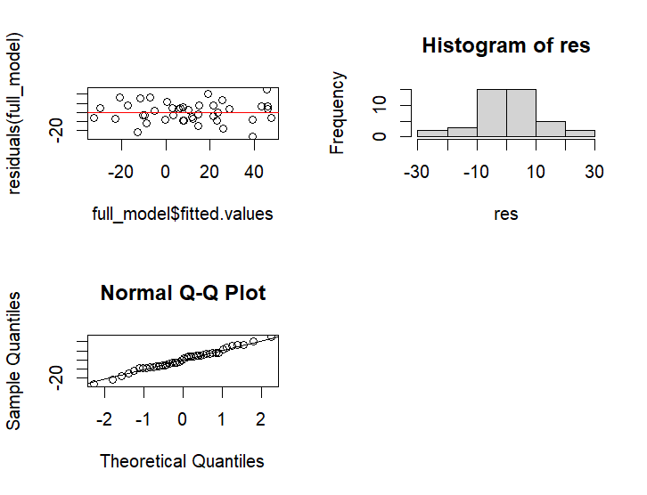
>
> # Stepwise regression
> step_model <- stepAIC(full_model,
+ direction = "both")
Start: AIC=230.82
NDIR ~ Unemp + Wage + Crime + Income + Metrop + Poor + Taxes +
Educ + BusFail + Temp + Region

Df Sum of Sq RSS AIC
- Taxes 1 2.4 5255.8 228.84
- Wage 1 10.1 5263.5 228.90
- Crime 1 12.2 5265.5 228.91
- Temp 1 13.8 5267.2 228.93
- Metrop 1 34.8 5288.1 229.09
- Educ 1 248.7 5502.1 230.76
<none> 5253.4 230.82
- Income 1 341.5 5594.9 231.46
- Unemp 1 381.5 5634.9 231.76
- Poor 1 644.9 5898.3 233.68
- BusFail 1 789.7 6043.0 234.70
- Region 3 8164.7 13418.1 264.20

Step: AIC=228.84
NDIR ~ Unemp + Wage + Crime + Income + Metrop + Poor + Educ +
BusFail + Temp + Region

Df Sum of Sq RSS AIC
- Wage 1 8.8 5264.6 226.91
- Temp 1 13.5 5269.3 226.94
- Crime 1 13.5 5269.3 226.94
- Metrop 1 36.2 5292.0 227.12
<none> 5255.8 228.84
- Educ 1 268.6 5524.5 228.93
- Unemp 1 435.7 5691.5 230.18
- Income 1 502.8 5758.6 230.67
+ Taxes 1 2.4 5253.4 230.82
- Poor 1 642.9 5898.7 231.68
- BusFail 1 792.4 6048.2 232.73
- Region 3 10447.9 15703.7 268.81

Step: AIC=226.91
NDIR ~ Unemp + Crime + Income + Metrop + Poor + Educ + BusFail +
Temp + Region

Df Sum of Sq RSS AIC
- Temp 1 6.7 5271.3 224.96
- Crime 1 14.3 5278.9 225.02
- Metrop 1 28.7 5293.3 225.13
<none> 5264.6 226.91
- Educ 1 261.9 5526.5 226.94
- Unemp 1 472.2 5736.9 228.51
- Income 1 498.5 5763.1 228.71
+ Wage 1 8.8 5255.8 228.84
+ Taxes 1 1.1 5263.5 228.90
- Poor 1 662.3 5926.9 229.88
- BusFail 1 789.7 6054.3 230.78
- Region 3 10447.4 15712.0 266.83

Step: AIC=224.96
NDIR ~ Unemp + Crime + Income + Metrop + Poor + Educ + BusFail +
Region

Df Sum of Sq RSS AIC
- Metrop 1 23.5 5294.8 223.15
- Crime 1 30.5 5301.8 223.20
<none> 5271.3 224.96
- Educ 1 285.8 5557.1 225.18
- Unemp 1 502.0 5773.3 226.78
+ Temp 1 6.7 5264.6 226.91
+ Wage 1 2.0 5269.3 226.94
+ Taxes 1 1.4 5269.9 226.95
- Income 1 567.3 5838.6 227.25
- Poor 1 658.6 5929.9 227.90
- BusFail 1 860.2 6131.5 229.31
- Region 3 11396.5 16667.8 267.31

Step: AIC=223.15
NDIR ~ Unemp + Crime + Income + Poor + Educ + BusFail + Region

Df Sum of Sq RSS AIC
- Crime 1 11.0 5305.8 221.23
<none> 5294.8 223.15
- Educ 1 265.5 5560.3 223.20
+ Metrop 1 23.5 5271.3 224.96
+ Taxes 1 3.1 5291.7 225.12
+ Temp 1 1.5 5293.3 225.13
+ Wage 1 0.3 5294.5 225.14
- Unemp 1 544.7 5839.4 225.26
- Poor 1 656.6 5951.4 226.06
- BusFail 1 842.2 6137.0 227.35
- Income 1 917.3 6212.0 227.86
- Region 3 11840.6 17135.3 266.47

Step: AIC=221.23
NDIR ~ Unemp + Income + Poor + Educ + BusFail + Region

Df Sum of Sq RSS AIC
<none> 5305.8 221.23
- Educ 1 279.9 5585.6 221.39
+ Crime 1 11.0 5294.8 223.15
+ Temp 1 9.0 5296.7 223.16
+ Taxes 1 4.1 5301.6 223.20
+ Metrop 1 4.0 5301.8 223.20
+ Wage 1 0.0 5305.7 223.23
- Unemp 1 536.8 5842.6 223.28
- Poor 1 654.4 5960.2 224.12
- BusFail 1 898.2 6203.9 225.80
- Income 1 1117.0 6422.8 227.26
- Region 3 12747.0 18052.8 266.66
> # Summary of best model
> summary(step_model)

Call:
lm(formula = NDIR ~ Unemp + Income + Poor + Educ + BusFail +
Region, data = new_data)

Residuals:
Min 1Q Median 3Q Max
-26.393 -6.932 1.188 6.074 26.570

Coefficients:
Estimate Std. Error t value Pr(>|t|)
(Intercept) 1.881e+02 7.411e+01 2.538 0.0161 *
Unemp -4.556e+00 2.493e+00 -1.827 0.0767 .
Income -1.860e-03 7.055e-04 -2.636 0.0127 *
Poor -2.222e+00 1.101e+00 -2.017 0.0518 .
Educ -1.177e+00 8.920e-01 -1.319 0.1961
BusFail 5.831e+01 2.467e+01 2.364 0.0241 *
RegionNortheast -1.959e+01 9.214e+00 -2.126 0.0410 *
RegionSouth 1.406e+01 7.306e+00 1.924 0.0630 .
RegionWest 4.333e+01 7.050e+00 6.146 6.29e-07 ***
---
Signif. codes: 0 ‘***’ 0.001 ‘**’ 0.01 ‘*’ 0.05 ‘.’ 0.1 ‘ ’ 1

Residual standard error: 12.68 on 33 degrees of freedom
Multiple R-squared: 0.7813, Adjusted R-squared: 0.7283
F-statistic: 14.74 on 8 and 33 DF, p-value: 6.752e-09

> vif(step_model)
GVIF Df GVIF^(1/(2*Df))
Unemp 2.296331 1 1.515365
Income 2.579712 1 1.606148
Poor 4.619788 1 2.149369
Educ 6.704051 1 2.589218
BusFail 1.814899 1 1.347182
Region 7.946816 3 1.412642
> par(mfrow=c(2,2))
> plot(step_model)
> anova(step_model)
Analysis of Variance Table

Response: NDIR
Df Sum Sq Mean Sq F value Pr(>F)
Unemp 1 1360.5 1360.5 8.4619 0.006444 **
Income 1 3889.5 3889.5 24.1917 2.345e-05 ***
Poor 1 197.0 197.0 1.2254 0.276308
Educ 1 482.1 482.1 2.9983 0.092692 .
BusFail 1 277.1 277.1 1.7234 0.198318
Region 3 12747.0 4249.0 26.4274 6.695e-09 ***
Residuals 33 5305.8 160.8
---
Signif. codes: 0 ‘***’ 0.001 ‘**’ 0.01 ‘*’ 0.05 ‘.’ 0.1 ‘ ’ 1
> anova(step_model,full_model)
Analysis of Variance Table

Model 1: NDIR ~ Unemp + Income + Poor + Educ + BusFail + Region
Model 2: NDIR ~ Unemp + Wage + Crime + Income + Metrop + Poor + Taxes +
Educ + BusFail + Temp + Region
Res.Df RSS Df Sum of Sq F Pr(>F)
1 33 5305.8
2 28 5253.4 5 52.379 0.0558 0.9978

>

